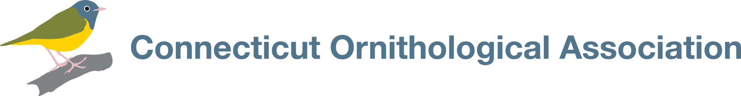
Zepko Audubon Camp Scholarship 2025 Application
The Connecticut Ornithological Association is pleased to announce that we will once again be offering Zepko Audubon Camp Scholarships to nurture interest in bird study and conservation among young birders. The 2025 Scholarships will cover the full cost ($1,725) for Coastal Maine Bird Studies for Teens. The cost includes housing, boat travel and all meals. The scholarship recipient will be responsible for transportation costs to and from camp. All participants must agree to the COVID-19 Camp Guidelines – please read before applying. https://hogisland.audubon.org/camperguidelines

This intensive 6-day, 5-night program on Hog Island allows enthusiastic young birders to work with some of the country’s best-known birders and ornithologists on field identification, bird ecology and conservation. Occurring concurrently with the adult Field Ornithology and Hands-on Bird Science sessions, and sharing many of the same instructors, this program includes the unique opportunity to see Audubon’s seabird restoration work in action.
Applicants must be a resident of Connecticut or active in a Connecticut birding organization, ages 14-17, and must submit a written application along with two letters of reference.
Completed applications and references must be received by the COA by January 31, 2025
Your Information:
There are two sessions
– Session One: June 8-13
– Session Two: June 25-20
Please indicate your session preference.
Choice 1: _____________ Choice 2: _____________ No Preference: ________
Name_____________________________________ Email_________________________________________
Address___________________________________ City______________________ Zip Code__________
Home phone______________________________ Cell phone__________________________________
Date of Birth_________________ Age as of June 1, 2025 ___________
Which most accurately describes you:
___ female ___ male ___ non- binary ___ other ___ I prefer not to say
Are you a COA member? (can be individual or family)_________________________
Name(s) of Parent or Legal Guardian__________________________________________________________
Email(s) of Parent or Legal Guardian___________________________________________________________
Address(es) of Parent(s) or Legal Guardian(s), if different from yours:
________________________________________________________________________________________
School name_____________________________________City and State_____________________________

Write a brief statement responding to the following two questions:
Which features of the Hog Island program most appeal to you? How would this program benefit you?

What have you done that you are most proud of, and why? (This need not be bird-related)

_________________________________________________________________________________________________
PERSONAL STATEMENT:
Write and attach a personal statement, no longer than 2 pages, telling us about the importance of birds in your life, your experiences as a birder (e.g. Christmas Bird Counts, projects, travel, independent birding), and the birding-related activities you most enjoy (e.g. drawing, photography, listing, teaching).
___________________________________________________________________________________________________________
LETTERS OF RECOMMENDATION
Your application must be accompanied by two letters of recommendation from adults who know your commitment to birding (e.g. teacher, mentor, nature center director). The letters may be included with your application or sent under separate cover.
___________________________________________________________________________________________________________
Send completed applications and letters of recommendation to Jo Fasciolo at jo_fasciolo@msn.com with the subject line ZEPKO APPLICATION 2025.
All components of the application must be received by January 31, 2015.
The announcement of the scholarship awards will be made by February 15, 2025.
___________________________________________________________________________________________________________
By signing this application, I represent that I am a resident of Connecticut or active in a CT birding organization and will be between 14 and 17 years old on June 1, 2025. I understand that the Zepko Audubon Camp Scholarship will cover only the camp tuition/fees of $1,725.00, and that the Zepko Audubon Camp Scholarship will be paid directly to National Audubon. I also understand that, if I am awarded a scholarship, I will make my best efforts to share my experiences with the Connecticut Ornithological Association.

_________________________________________________ ________________________________________________
Your signature and date Your parent’s/guardian signature and date

